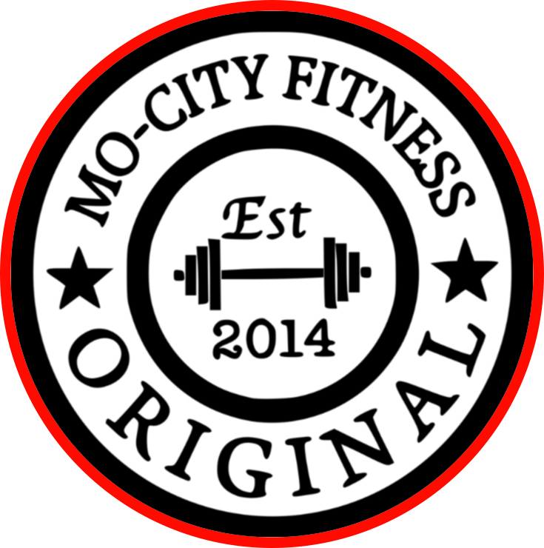

ARRC LED LIGHT THERAPY

TREATMENT FOR SKIN 1 day a week - 20 minutes MAX
Improves wound healing.
Reduces stretch marks.
Reduces wrinkles, fine lines and age spots.
Improves facial texture.
Improves psoriasis, rosacea and eczema.
Improves scars.
Improves sun-damaged skin.
Improves hair growth in people with androgenic alopecia.
Improves acne.
Sessions | Price
1 | $75
4 | $250
6 | $375
8 | $500

TREATMENT FOR PERFORMANCE (ATP) 2 days a week - 8 minutes MAX

Red Light Therapy is shown to build new arteries, repair nerve fibers, and rebuild cellular mitochondria.

These minute changes may not prove measurable unless a specific condition is present. The changes happen gradually over time.

The lights continue to improve baseline circulation, energy, detoxification, and minimize inflammation.

Light therapy may better be presented as a supplement than a treatment. What we want for ourselves and our members is to become and remain healthier, longer.

Sessions | Price
1 | $50
8 | $300
16 | $550
24 | $750

TREATMENT FOR INFLAMMATION
1 day a week - 20 minutes MAX
Sessions | Price
1 | $75
4 | $250
6 | $375
8 | $500
2 days a week - 5-10 minutes MAX
Sessions | Price
8 | $300
16 | $550
24 | $750

